(Approx. 306 words)

Review: TouchLock …
by George Harding, Treasurer, Tucson Computer Society
April 2018
www.aztcs.org/
actuary110 (at) yahoo.com

Security is important for us all, but even more important when you have to physically secure something. When you park your bike, you want to see it there when you return. A good lock is essential.

TouchLock is a good lock, one that cannot be easily defeated. It is an electronic device controlled by an app on your cell phone of other device.

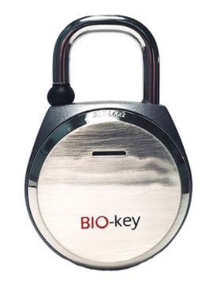
The big selling point for this lock is that it can be controlled biometrically. You can easily lock it in the usual manner by pressing the hook on the lock into its hole. Unlocking it can be done in two ways.

The company provides an app that may be used to unlock by Bluetooth. Bluetooth is a short distance wireless technology used today by many devices to avoid connecting wires.

The app requires you to register as administrator, then setting unlock and administrator passwords. Once these are set, you can unlock using the app with either the fingerprint touch or the password.

Additional users may be added by downloading the app onto the user’s phone. Control is accessed by entering the admin password.

The lock contains a battery that may be recharged using the included cable via USB. The company says the battery will last a year without recharging.

The lock is a heavy duty piece of hardware with an LED light on its front surface and a micro-USB slot for the charging cable. There is no key slot or combination wheel. It is all controlled by the app.

The TouchLock comes with the lock, charging cable and a heavy-duty cable for threading through a bike’s spokes and frame.

There are several versions of the TouchLock, varying both physically and by decoration.

TouchLock by Bio-Key bio-key.com Price $50

